Recovery Management

Planning Tool

Planning for Success

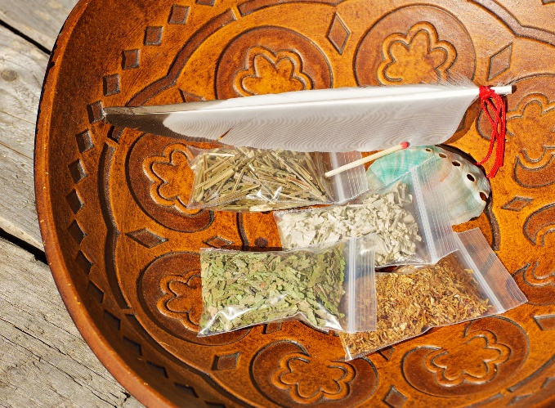
This is especially true when you become stressed, if you experience a break in your motivation, or if you find yourself facing temptation. You will discover that if you have a written management plan that is sufficiently detailed it will greatly improve your chances of sustaining your recovery efforts. Focus your plan on the next year.

In Part I, you’ll assess your recovery capital. Recovery Capital refers to your resources, or personal strengths in key areas of your life that you can use, rely on, or build on to strengthen your recovery. We make positive changes based upon our strengths, not on our weaknesses so recovery capital is essential to recovery management.

Part I: Recovery Capital Inventory

- Social Capital

Before you begin to write out a plan of action for your recovery, you need to first assess your current status. This Inventory helps you with that.

______I associate with other sober members of my community and have mentors that I look up to.
___ Ihave drug free friends who support my recovery
___ I have meaningful relationships with my family. This can include all extended relatives.
___I attend recovery related activities in my community, Examples: meetings, sober activities, classes, etc.
___I attend community based social events and activities. Examples: fun run and walks, powwows, health fairs, etc.
___
___I have access to elders and spiritual leaders for guidance, support, and education.

Deficit area[s] I need to work on:
ORGANIZE
It’s time for a change. Plan your work each day in advance. Leave free time for children, hobbies and relationships

REVIEW
Use a notebook for weekly planning. Schedule your time.

Check Your Plan Check your Plan 1st thing in the morning. Planning will only help you if you follow the Plan.
1

Human Capital

I have the following skills:

I have goals: [list them]

I have a good sense of balance in the areas of my mental, physical, emotional, and spiritual health.

I live in the present moment and have a positive outlook regarding my future.

Service to others, my community, and my nation as whole is now an important part of my life.

I believe I have personal resources: [list some]

As a native person, my unique understanding of my life
experiences and my surroundings help me to understand my path
has led me right to this place in time and my life has a purpose.

Deficit areas I need to work on:

Physical Capital

_ I have health insurance
_I have access to healthcare services and seek service when needed

I have sufficient financial resources to cover my expenses

I have a job/employment that is meaningful and supportive of my recovery

I have safe, drug free, affordable housing

I have transportation
__I am aware of all the services available to me and am aware of how and where to acquire them.

Deficit Areas I need to work on:

Cultural Capital

I understand the medicine wheel or other equivalent sources of spiritual guidance to my specific traditional beliefs.

I have possession of or access to traditional medicines used to heal and cleanse. Examples: sage, cedar, sweetgrass, etc.
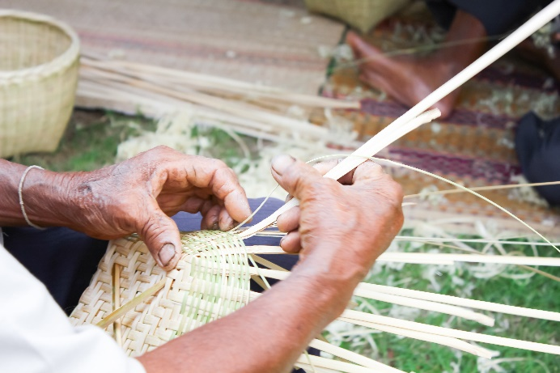
__ I attend or participate in ceremonial practices.

__ I participate in other culturally relevant activities. Examples: hunting, fishing, gathering, beadwork, horsemanship, etc.

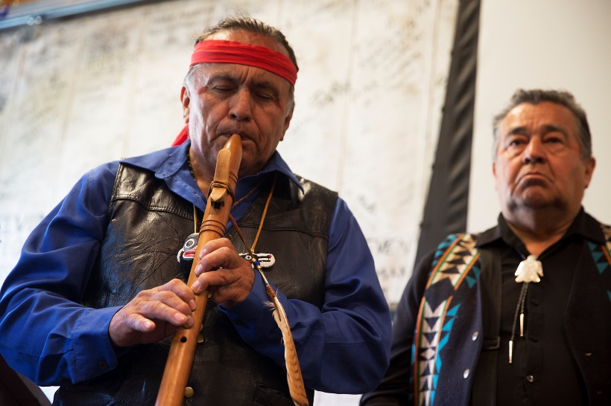

I have access to elders and spiritual leaders for guidance, support, and education.

and some of these are:

Deficit Areas I need to work on:

Part II: Relapse Prevention Plan

My goal is to use my recovery capital to maintain an abstinence-based lifestyle. In order to do this:

I will fully commit to use the recovery capital assets listed in my recovery management planning tool.

I will reach out to my mentor/sponsor, relatives, friends, community members, elders, spiritual leaders, recovery community, higher power, and/or any other positive resource for support when I am feeling weak or experiencing a need to drink or use or I

am having trouble staying positive in my program.

These are the People / Things I will avoid or change:

People:

Places:

Things:

These are my high-risk times and situations and my plans to manage them:

Times/Situations | Action Plans

These are the current problems and/or relationships I need to repair or take accountability for:

I will use the following to be proactive and manage my cravings:

If I am exhibiting the following symptoms of relapse:

Planning for Success

Recovery Capital
Your recovery will be based on your resources and strengths

Time
Schedule the time needed to accomplish your tasks. Stay focused and prepare for unexpected things that pop up.

I give my Family permission to confront me and /or seek outside intervention to help me.

Signature Date:
Communicate Communicate your written plan with a trusted family member.

Experience has taught us that tailoring a personal plan to your own situation can make the difference between success or failure

