PIF Form Instructions
Prepared by Office of Court Administration
Updated: Oct 2017

- Fiscal Year Covered. Select from the drop-down list, the appropriate fiscal year funds you are using. List the PIF plan year on each bill submitted to the finance office for payment.

- New or Revised Plan. Select from the drop-down list, whether you are submitting a new plan for the fiscal year, or revising a plan that was previously submitted.

- Judicial District. Select your judicial district from the drop-down list.

- For District. Select the judicial district that you are funding a PIF plan for. This will default to N/A.

- Program Name. Enter the name of your PIF plan.

- Who is the Contractor/Provider? Enter the provider or provider(s) who will be submitting bills to you.

- Was Program Previously Grant Funded? Select ‘Yes’ from the drop-down list if you are requesting PIF money to replace grant money that had been previously used to fund the placement, program, or service. If you select ‘Yes’, submit evidence that the program’s demonstrated outcomes have resulted in a reduction in out-of-home placements.

- Was Program Previously PIF Funded? Select ‘Yes’ from the drop-down list if this program was previously PIF funded.

- Estimated Cost. Indicate the total cost of the program

- Approx. Number of Youth/Families to be Served. Estimate the total of all juveniles to be served by the placement, program, or service.

- Estimated Cost calculation: Indicate the cost breakdown in how you arrived at the total Estimated Cost (above) of the program. The total cost calculation must be based on a unit of measure such as number of youth served, cost per hour, cost per day, etc.

- All Services provided with this PIF Plan will be entered into JCATS as follows:
The Service, Provider, and Funding Source you enter in this section should exactly match the way you will enter these services (by youth) in JCATS via the Service Module.

Note: If you need more than the 5 rows provided in the table, please refer to the Appendix of this document for instructions on how un-protect the document and add additional rows.

- Service: Select from the drop-down list, the service or services this PIF plan will provide. These will be the services you are going to enter into JCATS.
The following are special plan situations:

- Evaluation/Counseling/Assessment Plans: For those plans that provide all types of evaluations, counseling, and/or assessments by multiple providers: Select Evaluation (ALL TYPES), Counseling (ALL TYPES), and/or Assessment (ALL TYPES) instead of each individual type of that service.
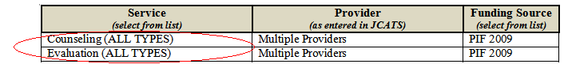

Note: When you indicate a service with (ALL TYPES) as shown above, you still must enter the actual type of evaluation, counseling or assessment that the youth received when entering the data in JCATS. For example: Counseling – Family, Counseling – Individual, etc.

- Placement Plans: For those plans that are for youth placements instead of services: Select Placement as the service, to indicate that the youth did not receive a service, but will be instead entered in the JCATS Placement module. Remember, you must enter these placements into JCATS with the PIF funding source.
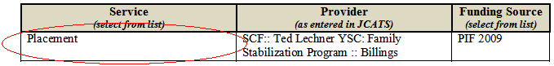

- Provider: Enter the provider or providers that will be receiving the payments for this service. This should be the same as the Who is the Contractor/Provider entered above. It is important that the provider names listed here are exactly as they will be entered in JCATS. Remember that the provider is specific to an individual district and is entered into the JCATS provider list by the Chief JPO.
The following are special plan:

- Multiple providers for a service: For those plans using multiple providers for a service and/or all of the providers are not yet known, enter Multiple Providers. This will most often be the case with the following types of plans:

- Evaluation/Counseling/Assessment Plans:
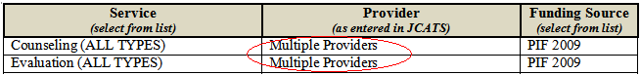

- Family Support Services Plan:
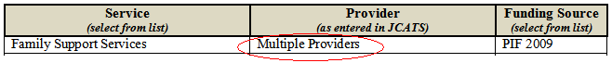

Note: When you indicate “Multiple Providers” for a service as shown above, you still must enter the actual provider’s name(s) when entering the data in JCATS. The entry “Multiple Providers” should not be in your provider list in JCATS!

- Funding Source: Select the year of the PIF plan from the drop-down list. This will also be the Funding Source you will enter in JCATS when entering corresponding youth services.

- Program Narrative. Thoroughly describe the placement, program, or service to be provided. Identify the population to be served and who may make referrals to the placement, program, or service. If more than one program or service is to be provided, describe each of them.

- Proposal presumed to be a service. If funds are to be used for evaluations, assessments, or other types of services that do not require outcome measures, select ‘Yes’ from the drop-down list labeled “This proposal is presumed to be a service not requiring further explanation (e.g., sex offender evaluation, psychological evaluation, drug and alcohol evaluation, etc).” If you select ‘Yes’, do not complete the remainder of the form except for obtaining the required signatures at the end of the form. (Note: If the Cost Containment Review Panel determines that the service requires outcome measures, you may be asked to complete the form in its entirety.)

- Risk Factor Present in Youth Being Served by Program. Select from three drop-down lists, the type of risk factors present in youth to be referred to the placement, program, or service. The risk factors listed are those domains present in the full Back on Track risk assessment tool and can easily be monitored for progress or the lack thereof by re-assessing the youth upon completion of the placement, service, or program.

- Outcome Measures to be Used. Two outcome measures are required on every PIF plan, one of which must be Recidivism. The second outcome measure can be selected from the drop-down list of values

- Explanation as to how you will evaluate outcome measures.
- For the Recidivism outcome measure, you can simply run the PIF Plan Recidivism Report in JCATS.
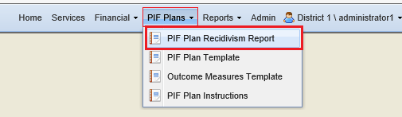

- “Check” / enter the appropriate parameters
- Select the Funding Source(s)
- Select the Service(s) Provided
- Select the Provider(s)
- Enter the Service Date between (start date and end date) dates of the program

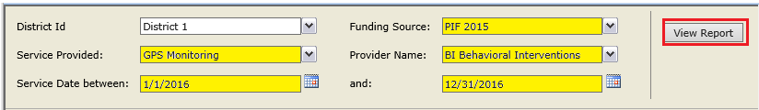

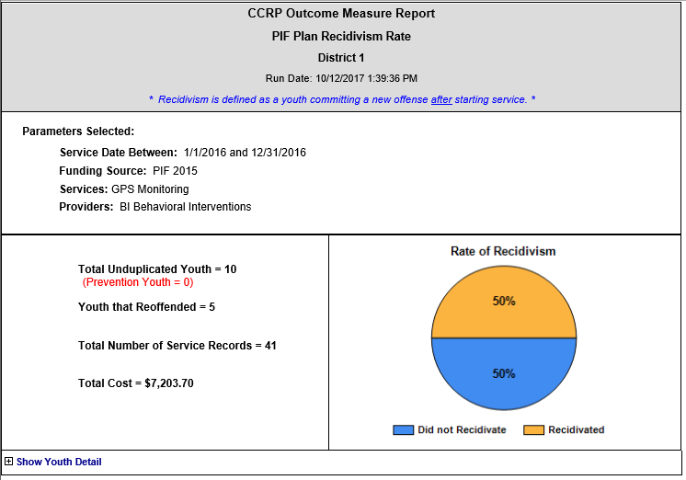

If you want to see detail information, press the + Show Youth Detail near the bottom of the report.

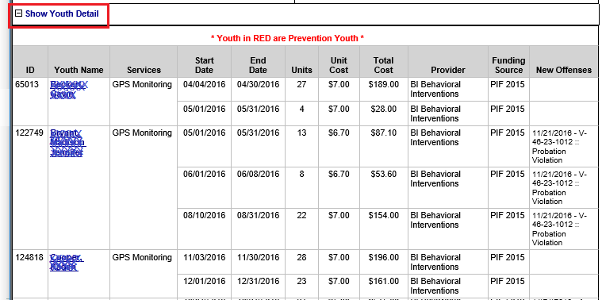

- For the second selected outcome measure, explain how you will evaluate the outcome measure. Indicate who will be responsible for evaluating the outcome measure. In most cases, the placement, service, or program provider (e.g., the contractor) should be responsible for providing an outcome report based upon the measures selected. The contract should clearly state that the contractor is responsible for reporting on the outcome measures.

Additional Notes:

- The information contained in the PIF form under Program Narrative and Outcome Measures to be Used should be included in the SERVICES AND/OR SUPPLIES section of the contract. Again, if the contractor is responsible for providing an outcome report based upon the measures selected in the PIF form, the contract must clearly state so.

- If you are not going to continue a program or service after the contract period is up, you will be required to submit an outcome report to the Office of Court Administrator by August 31 describing the results of the outcome measures for each placement, service, and program that received PIF funding for the previous fiscal year. If you are going to submit a new PIF plan to continue a program, service, or placement you will need to submit the outcome report at the same time you submit the new PIF plan. If the outcome report does not accompany an ongoing PIF plan, it will be denied by the CCRP.

Appendix:

How to insert additional rows into the Service/Provider/Funding Source table:
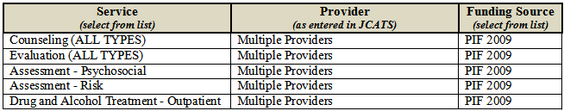

- Click on the “Review” on menu.
- Click on the “Protect Document” icon on the quick access toolbar (this should display a new menu).
- Click on the “Restrict Formatting and Editing” menu option.
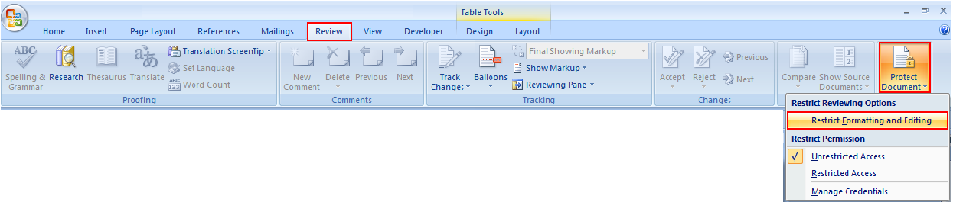

- A new task pane (“Restrict Formatting and Editing”) should appear at the right hand of your screen.
- Click on the “Stop Protection” button at the bottom of the task pane.
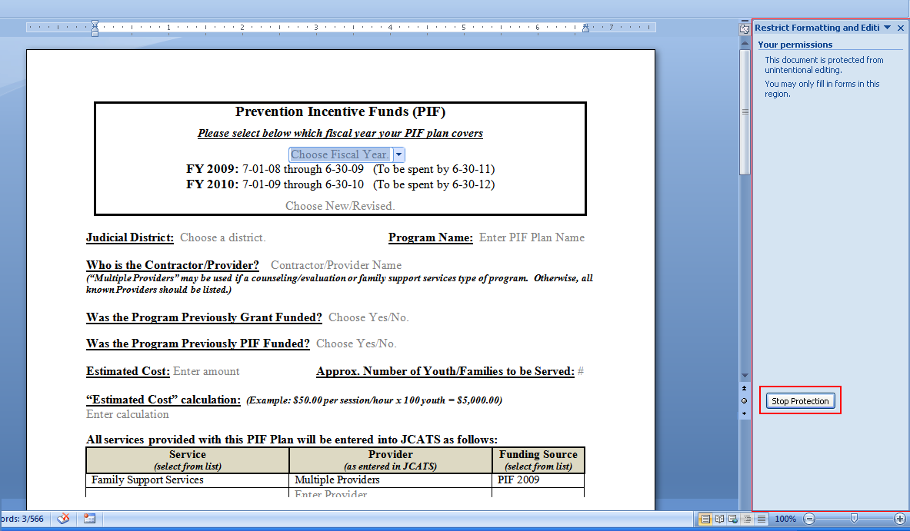

- The document is now “unprotected” and you can insert new rows in the table.
- To insert new rows, put your cursor in the last row of the table.
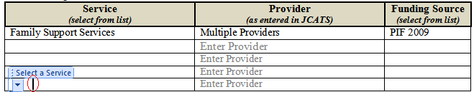

- Right-click on the mouse (while your cursor is in the last row … field doesn’t matter). This should bring up a new menu.
- Click on “Insert” menu option.
- Click on the “Insert Rows Below” menu option.
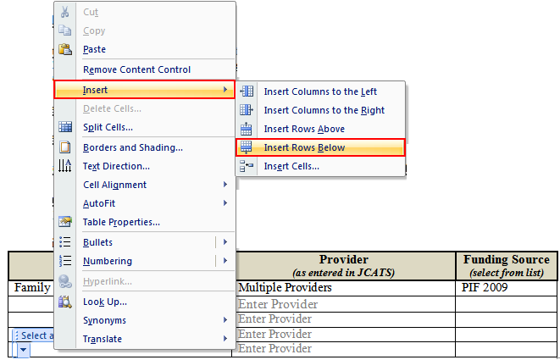

- A new row should now be inserted at the bottom of the table. The new row will not have the drop-down lists for Service and Funding Source. You will have to manually enter all of the fields in the new rows.
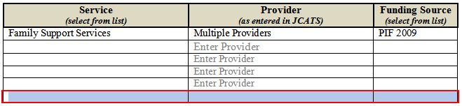

- Repeat steps 7 – 10 to insert additional rows.
- When you are done inserting new rows, you should re-protect the document, as it will function better in “protection” mode.
- The task pane should still be displayed at the right side of your screen. (If it is not still displayed, repeat steps 1-3 to display it again.)

- Click on the “Yes, Start Enforcing Protection” button.
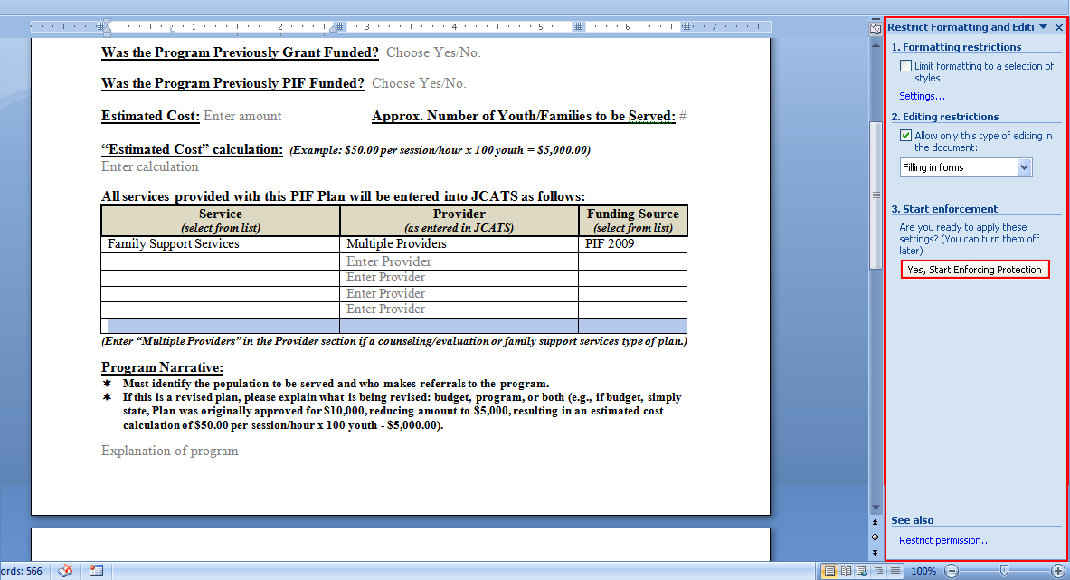

- A pop-up box will appear prompting you for a password. Do not enter a password; just click the “OK” button.
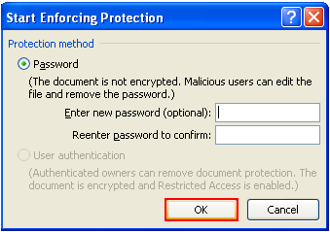

- You should now be back in “Protection” mode. You can close the task pane on the right side of your screen by clicking on the “X” in the upper right-hand corner.
