Prior to submitting a PIF bill to accounting, please follow the directions below:

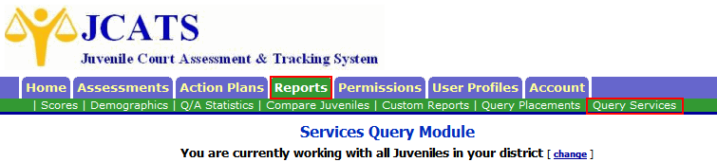

- On the Services Query Module, define your query based on the parameters for that PIF plan.

SERVICE PROVIDED:
• If a single service plan, then select only that service
• If plan provides multiple services, then select all services provided by the plan
(Hold down [Ctrl] key to select multiple items).
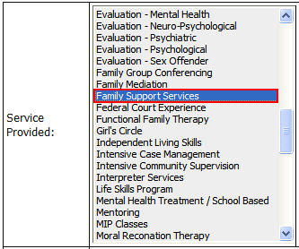

SERVICE DATE:
• Enter the monthly billing period. For example, March 2011 would look as follows:

PROVIDER NAME:
• If a single provider, then select only that provider
• If plan is contracted to a known, set number of providers, then you can select all of them (Hold down the [Ctrl] key to select multiple items).
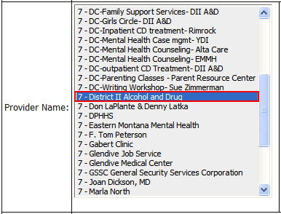

Remember within each PIF plan, you should be able to pick either one service or one provider for your query. The only exception should be for Evaluation and/or Counseling plans.

FUNDING SOURCE:
• Select the all PIF-related funding sources that are used in your district. If you are unsure which are used, select all of them.
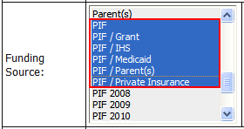

Special Plan situations:

• Evaluations and/or Counseling Plans:
These types of plans have multiple services and providers. Although all of the providers may not be known, all of the services to be provided should be. Therefore, it is most effective to query only on the Services Provided as shown below.

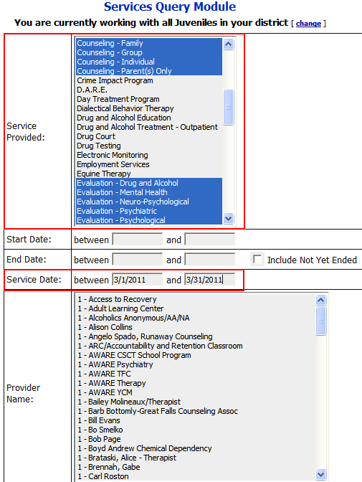

To select multiple services:
Select the first item;
Hold down the [Ctrl] key;
Select additional items

Always use Service Date for date range

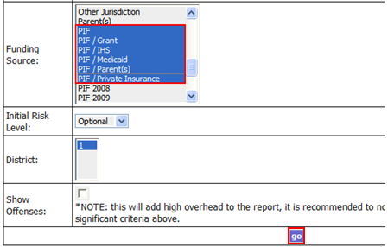

To select a block of items:
Select the first item;
Hold down the [Shift] key;
Select the last item

Press the “go” button to execute the query and show the results.
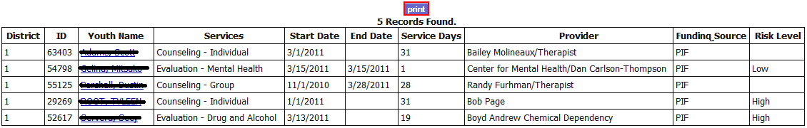
- The results of your query will display as follows. Print a copy of the report and submit it with your PIF invoice to be paid.

- Beginning with FY2010 PIF funds, we are no longer using the generic and split PIF funding sources such as: PIF, PIF/GRANT, PIF/IHS, PIF/Medicaid, PIF/Parent(s), and PIF/Private Insurance.
IMPORTANT: All services that will be paid for with 2010 PIF money should be entered with
PIF 2010 as the Funding Source.

